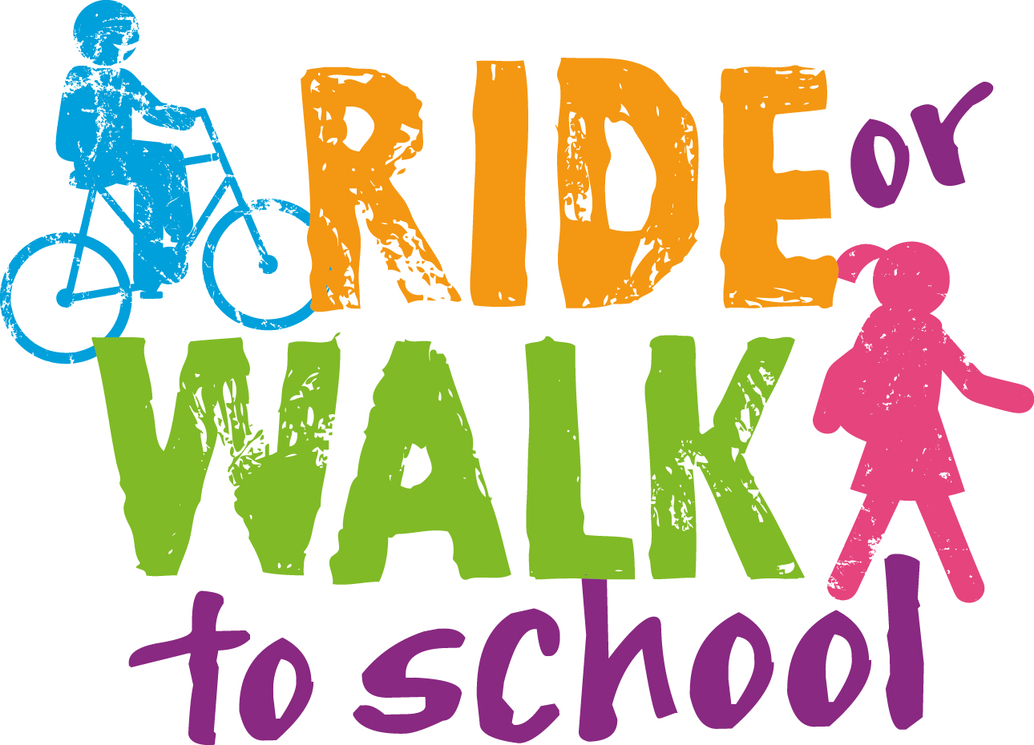
RIDE OR WALK TO SCHOOL PROGRESS REPORT

School Name
Date

EVENTS
 | Did your school participate in the following events? | How did you promote it? | What activities did you do on the day? | What impact did this have on your students / school?  eg skills developed, changes in behaviour | Other comments / feedback?
National Ride 2 School Day (Term 1)
Walk Safely to School Day (Term 2)
TEACHING RESOURCES
 | Have you used the following teaching resources? | Which year groups was it used with? | What impact did this have on your students / school?  eg skills developed, changes in behaviour | Other comments / feedback?
Challenges & Choices
Safe Cycle
WORKSHOPS
Core activities | Has your school participated in this yet? | If yes......  What year(s) participated? | What impact did this have on your students / school?  eg skills developed, changes in behaviour | Other comments / feedback?
ACTION Bus Safety Program
BMX Workshops
Self Defence Workshops
Constable Kenny Koala
OTHER EVENTS & ACTIVITIES
Please provide information about any other riding or walking activities that have taken place or will take place at your school. | What date did it take place? Or What date will it take place? | What year(s) participated? | How many students participated? | What impact did this have on your students / school? | Other comments / feedback?
LEADERSHIP
Who has been involved in leading / coordinating RWTS activities/events? | What is their normal role? | What have they done?
Outline how students have had input into events and activities

MARKETING & COMMUNICATIONS
What marketing and communications have taken place for the following groups?
Students
Parents
Teachers
Local residents
Other (please specify)
EQUIPMENT
What years have you been using the bikes with?
Are the bikes a good size for your students?
Do you have any safety concerns with the bikes?
Are there any of the bikes that the STUDENTS don’t like riding?
Do the STUDENTS have a preference for one style of bike over the other? Eg BMX or MTB
Do you think the bikes are good quality?
Do you think the helmets are good quality?
Do you have any safety concerns with the helmets?
Is your bike maintenance kit useful and sufficient?
Do you have any other comments about the bikes, helmets or maintenance kits?
What bike maintenance has taken place?
What helmet care is taking place?
PHYSICAL ENVIRONMENT
Storage for school bikes |  | Student bike storage
Is your storage space adequate? |  | Is your storage space adequate?
How are they secured? |  | How are they secured?
How do teachers access the bikes? |  | How do students access the storage / bikes?
Outline any improvements you’ve made to your bike storage facilities
Outline any bike storage issues you are having
Outline any plans you have for improvements to your bike storage facilities
Outline any improvements made to the road and traffic environment in or around the school over the last 12 months.
OBSERVATIONS
Have you observed more students riding and walking to school?
Have you observed an increase in the number of bikes/scooters/skateboards in the bike racks?
OTHER
Please provide any other information or comments you have about the Ride or Walk to School Program

Name of person who completed this report

