[Insert school logo or letter head]
[DD MMMM 2016]

Dear Parent

Our school is participating in the Ride or Walk to School Program, an initiative to encourage more students to be active on the way to school instead of coming in the car.

As part of this initiative students will be learning about road, pedestrian and cycle safety. To complement this, students will also have the opportunity to participate in a range of cycling activities.

Your child’s class will be participating in a BMX workshop on [DD MMMM YYYY] at the school. This is designed to increase your child’s confidence on a bike and introduce them to BMX riding. The workshop will be conducted by BMX Australia qualified coaches from FACT BMX Club and will be supervised by a teacher.

A number of bikes and helmets will be provided by the school and FACT BMX, however your child is encouraged to bring their own helmet and BMX to use in the workshop if they have one. Please note that the BMX coaches will need to conduct a safety check on the bike before your child will be allowed to use it in the workshop.

Students will not be taught basic riding skills, this workshop is only suitable for students who already know how to ride a bike.

If you believe your child is competent to participate in the BMX workshop please complete and return the consent form.

Students who have not returned their consent form will not be permitted to participate in the workshop.

Yours sincerely

[Enter Name]


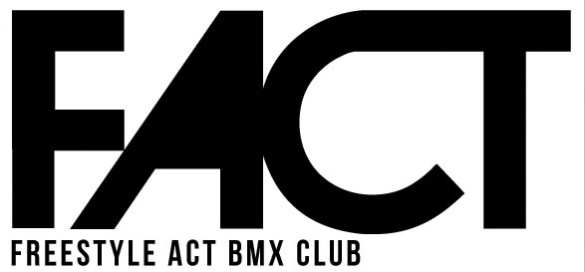
Rider Information and Consent Form
for participation in BMX Coaching Sessions
Riders (Child’s) Details
Name
Gender | Female □ Male □
DoB
Address
Emergency Contact Details
Name
Relationship to rider
Phone
Medical and Specific Needs:
Please give details of any medical/health conditions or any specific needs that might affect your participation in BMX and what support/modifications are needed:

Consent, release and indemnity:
I release and forever discharge BMX Australia Inc and FACT BMX Club from all actions, suits, proceedings, claims, demands, losses, damages, penalties, costs and expenses however arising that I may have or may have had but for this release arising from or in connection with our participation of this coaching sessions; and I indemnify BMXA and FACT BMX Club to the extent permitted under the Trade Practices Act 1974 (Cth) or otherwise by law in respect of any actions, suits, proceedings, claims, demands, losses, damages, costs, expenses, penalties and fines arising as a result or in connection with the coaching session and my participation in the coaching session whether caused or contributed to, directly or indirectly, by any act or omission (including negligence) on part of BMXA and FACT BMX Club.

I have read the information on this form, and consent to myself/ my child taking part in the coaching session. I understand and agree that I/ my son/daughter participates under the instruction of BMX coaches entirely at his/her own risk. I have considered the nature of such sessions (and have discussed them with my son/daughter). I am satisfied that I/ my son/daughter is sufficiently responsible and competent to assume full and entire responsibility for his/her own safety under the supervision of a BMX coach.

Signature ___________________________________ Date____________________

In the case of participants under the age of 18 years, this form must be signed by his/ her parent or legal guardian

