[Insert school logo or letter head]
[DD MM YYYY]

Dear parents and carers

Our school is involved in the Ride or Walk to School program (RWTS). This program is designed to encourage students to use active forms of travel such as riding, walking or catching public transport to get to and from school.

As part of this program, this term, your child will be participating in Safe Cycle. This is an Australian Curriculum aligned course with practical lessons designed to teach students how to cycle safely. Students will be using bikes during the practical classes to help develop their skills and confidence through a range of fun, exciting and informative lesson plans.

Students who own or can access a bicycle and helmet, that are in a fit and roadworthy condition, are requested to bring these to school for use in the Safe Cycle training. Students’ own bikes and helmets will not be shared with other students. We will have access to a limited number of loan bikes and helmets during the Safe Cycle training that are prioritised for students who do not have their own bikes.

If your child will be bringing their own bike and/or helmet, please review and complete the attached Information and Permission Form. It is recommended that you complete a safety check of your child’s bike and/or helmet prior to the training using the attached ABC TIGHT Bike Safety Check List and the Three 2s Helmet Check. During the day students can lock their bikes in the <<< insert details of school bike storage facilities>>

RWTS is an inclusive program that caters for students of all abilities. This includes students who do not ride bikes, through to competent cyclists. Safe Cycle builds on the confidence and skill development of each student and participants are encouraged to work at a level that is within their comfort zone.

You are encouraged to get involved too. Your child will have the most success in RWTS if they practise at home. Adults role modelling safe cycling practices will further enhance the impact of the program and reinforce positive cycling behaviours. Please visit the online Safe Cycle for Families resource which covers a range of topics you can click into from teaching your child to ride through to basic bike maintenance. We have also attached “Tips for beginner cyclists” for information about how to support people who are hesitant or still learning to ride.

If you have any questions regarding the program please contact your child’s classroom teacher or our RWTS coordinator, (Insert Name).

Yours sincerely

[Enter Name]

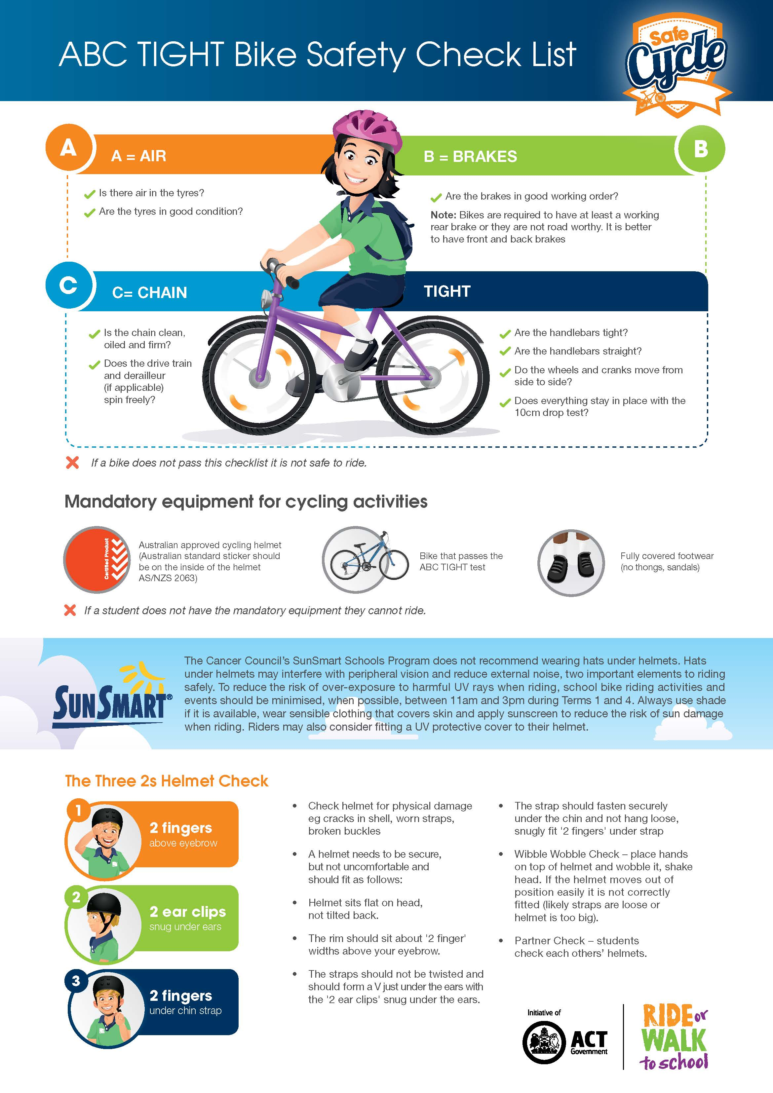

Parent/Carer Information and Permission Form
child bringing own bike and/or helmet to school for
Safe Cycle training

I _______________________________________ consent to my child/dependent,

____________________________________________________________________________

(tick as appropriate)
□ bringing their own OR □ using a school provided
□ roadworthy bicycle of suitable size for my child’s/dependent’s height
□ appropriately sized Australian Standard helmet

for use in Safe Cycle training.

I understand and agree that the equipment that my child provides for this training is in a fit and roadworthy condition. I understand that this equipment will not be shared with other students. I understand that it is my child’s responsibility to ensure his/her bike is safely locked up using the school’s bike storage facilities. I understand that my child will not be permitted to ride without wearing a helmet.

Parent / Guardian Signature ___________________________________ Date________________

What you need to do:
- Return this permission note to your child’s classroom teacher
- Make arrangements to bring your child’s bike/helmet to school at X.XXam on the XX Month 201X for use over x days
- Securely leave the bike << insert details of where the bikes should be left>>
- Assess the bike after each day of the Safe Cycle training to review its condition

Tips for beginner cyclists

Helpful
tips

There is a common misconception that if a child hasn’t learnt to ride before they have outgrown kids bikes with training wheels, they’ve ‘missed the boat’. This doesn’t have to be the case! Here are some tips to get them pedalling! Remember to keep it fun and use games to practice.

- Practise in a traffic-free area - find a place that is large, flat, smooth and grassy or paved.
- Properly inflate the tyres, it will help avoid punctures and make a smoother ride. Look for the recommended pressure printed on the tyre sidewalls.
- Remove pedals using a pedal wrench and lower the seat until the rider can put both feet on the ground when standing over the frame.
- Emphasise balance first and pedalling later.
- Check hands are placed on the grips of the handlebars.
- Remain stationery - practise balancing on the bike.
  - Lift one foot off the ground
  - Shift weight onto other foot
  - Repeat on the other side, rocking left to right
  - Try lifting both feet at the same time
- Start moving, try scooting off one foot at a time so they can get the feel of balancing.
- Once adept at scooting, challenge them to push forward off the ground using both feet, pick up both feet and coast. Practice looking ahead.
- Once they have mastered the ability to scoot and coast the bike move on to turning and steering. Start with big, easy, looping turns.
- Once the rider masters coasting, turning and looking ahead while riding, it's time to put the pedals back on the bike. For now, keep the seat in its lowered position so the rider can put both feet on the ground to stop.
- Practise moving from a stopped positioned using the power pedal. The “power pedal” position allows the rider to have the most powerful first pedal stroke, resulting in a smoother and faster start
  - Identify dominant foot (same side as the hand you write with)
  - Align pedal of dominant foot with bike frame down tube
  - Place dominant foot on the pedal
  - Transfer weight and drive the pedal down
- Steady the rider as he or she moves forward by placing a hand on a shoulder or the bike saddle - but let them learn how to balance and feel comfortable on the bike without assistance.
- As they get the hang of pedalling a bike, they can start practicing turns. Encourage them to do large circles and figure 8's.
- Practise gently pressing on the coaster brake until they can use it without wobbling very much.
- Once they can ride easily, get on your bike and have them follow you.

